**HARDWARE ARCHITECTURE:**

The hardware of Snake-Bot primarily consists of building blocks, in this case five, motion between which is controlled by the Servo Motors (SG90 Micro-Servo). The Servo motors are driven by external 5V power supply from the LM2596 DC to DC buck regulator to provide adequate current to the motors as well as supply the NodeMCU. The angle of motion for each Servo is calculated and controlled via NodeMCU using Servo Library which provides the required PWM wave for servo rotation. On the top, the Wi-Fi application communicates with the NodeMCU to provide motion commands using in built ESP8266 Wi-Fi Library.

**CIRCUIT DIAGRAM:**

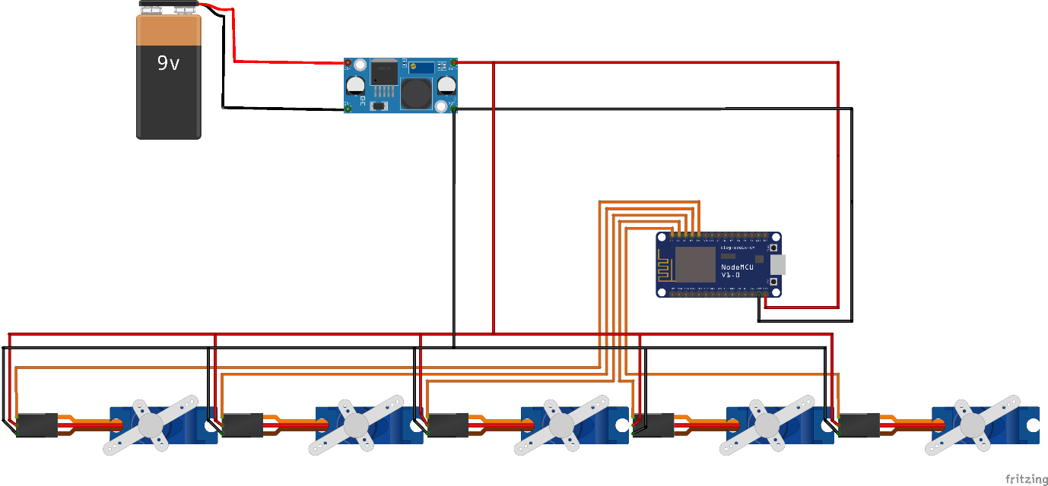

Fig: The Circuit diagram of NodeMCU Wi-Fi controlled 5-servo configuration for a 5-joint Serpent Bot.

**COMPONENT DESCRIPTION:**

|  |  |  |
| --- | --- | --- |
| Sl. No. | Components | Quantity |
| 1 | NodeMCU 0.9 (ESP8266) | 1 |
| 2 | SG90 Micro-Servo Motors | 5 |
| 3 | LM2596 Buck Regulator | 3 |
| 4 | Lithium-ion Batteries | 1 |
| 5 | Connecting Jumper Wires |  |

1. **NodeMCU**

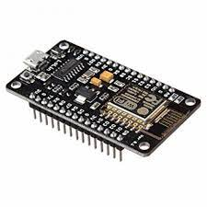

Fig: NodeMCU

NodeMCU is an open-source firmware for which open-source prototyping board designs are available. The name "NodeMCU" combines "node" and "MCU" (micro-controller unit). The term "NodeMCU" strictly speaking refers to the firmware rather than the associated development kits. Both the firmware and prototyping board designs are open source. The firmware uses the Lua scripting language. The firmware is based on the eLua project, and built on the Espressif Non-OS SDK for ESP8266. It uses many open-source projects, such as lua-cjson and SPIFFS. Due to resource constraints, users need to select the modules relevant for their project and build a firmware tailored to their needs. Support for the 32-bit ESP32 has also been implemented. The prototyping hardware typically used is a circuit board functioning as a dual in-line package (DIP) which integrates a USB controller with a smaller surface-mounted board containing the MCU and antenna. The choice of the DIP format allows for easy prototyping on breadboards. The design was initially based on the ESP-12 module of the ESP8266, which is a Wi-Fi SoC integrated with a Tensilica Xtensa LX106 core, widely used in IoT applications.

1. **SG90 Micro-Servo Motor:**

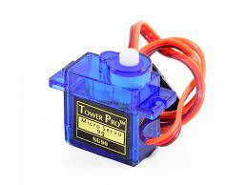

Fig: SG90 Servo Motor

Tiny and lightweight with high output power. Servo can rotate approximately180 degrees (90 in each direction), and works just like the standard kinds but smaller. You can use any servo code, hardware or library to control these servos. Good for beginners who want to make stuff move without building a motor controller with feedback & gear box, especially since it will fit in small places. It comes with 3 horns (arms) and hardware.

Specifications

• Weight: 9 g

• Dimension: 22.2 x 11.8 x 31 mm approx.

• Stall torque: 1.8 kgf·cm

• Operating speed: 0.1 s/60 degree

• Operating voltage: 4.8 V (~5V)

• Dead band width: 10μs

• Temperature range: 0 ºC – 55 ºC

• Position "0" (1.5ms pulse) is middle, "90" (~2ms pulse) is all the way to the left.ms pulse) is all the way to the right, ""-90" (~1ms pulse) is all the way to the left.

1. **LM2596 Buck Regulator**

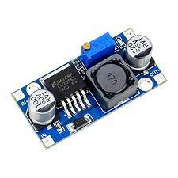

The LM2596 series of regulators are monolithic integrated circuits that provide all the active functions for a step-down (buck) switching regulator, capable of driving a 3-A load with excellent line and load regulation. These devices are available in fixed output voltages of 3.3 V, 5 V, 12 V, and an adjustable output version. Requiring a minimum number of external components, these regulators are simple to use and include internal frequency compensation, and a fixedfrequency oscillator. The LM2596 series operates at a switching frequency of 150 kHz, thus allowing smaller sized filter components than what would be required with lower frequency switching regulators. Available in a standard 5-pin TO-220 package with several different lead bend options, and a 5-pin TO-263 surface mount package.

**SOFTWARE ARCHITECTURE**

The Serpent-Bot is built on NodeMCU ESP8266 module which has a built-in Wi-Fi. The firmware for NodeMCU is made in Arduino IDE with ESP8266 board setup.

The Flowchart representation of NodeMCU software architecture:

Start

While 1

If command received (Wi-Fi)

no

yes

Command-value: f/b/l/r/s?

no

The module is configured as a Wi-Fi web server using ESP8266WebServer library, to receive move commands from the client.

End

Write Servo angles via I2C: Move according to command

Calculate Angles for Servos: forward/backward/right/left/stop